Pioneer Clubs® Member Registration Form

Club Year 2020-2021

Club member name Age Birth date Grade School Address City State Zip/Postal Code Home Phone Work phone Mother’s Name Cell phone Father’s Name Cell phone Email address Belongs to: Home church Doctor’s name Phone Allergies

Special instructions or information about child:

Person(s) authorized to pick up child:

Emergency contact if parent or guardian cannot be reached:
Name Relationship
Emergency contact phone
I give my permission to the staff of LUMC to seek medical attention for my child if necessary while participating in Pioneer Club functions. I understand that all necessary precautions will be taken for my child’s safety. I will not hold the church, its staff, or those supervising liable.
Photo Release: I hereby grant the LUMC permission to copyright and use photographs/videos taken at Pioneer Club of the minor designated above in any manor or form for any purpose lawful at any time. I waive any right that I may have to inspect or approve the finished product or written copy, that may be used in conjunction therewith, or the use to which it may be applied.
____Please Initial if your child has permission to ride or walk to and from Pioneer Club

CONTINUE ON THE BACK
SIGNATURE REQUIRED

The LUMC has put into place preventative measures of sanitation and distancing to reduce the spread of COVID-19; however, the LUMC, cannot guarantee that your child or anyone they come in contact with will not become infected with COVID-19.

By signing this agreement, I acknowledge the contagious nature of COVID-19 and voluntarily assume the risk that my child may be exposed to or infected by COVID-19 by attending Pioneer Club and that such exposure or infection may result in personal injury, illness, permanent disability, or death to me and/or to those people I come in close contact with.

I hereby release, hold harmless, and discharge from all liability the LUMC and its volunteers from all liabilities, claims, actions, damages, costs or expenses of any kind, whether my child contracts COVID-19 infection before, during or after their attendance at Pioneer Club.

_______________________________________ ________________________
Parent/Guardian Signature Date

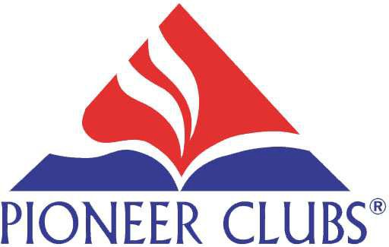
CLUB FEES:
Registration Fee $5.00 per child $10.00 per family

Cash ___ Check #________

Date Paid _____________________

www.pioneerclubs.org

